

Cloud Live Tech Solar (GaoYou)Co. Ltd

INSTALLATION MANUAL OF CONVENTIONAL SOLAR PV MODULES

 **Important Safety Instructions**

* *This installation manual provides information on the installation and safe use of photovoltaic modules (hereinafter referred to as "* *modules ") of* *Cloud Live Tech Solar. All safety precautions and local regulations in this guide should be observed in modules installation and daily maintenance.*
* *Installing modules systems requires professional skills and knowledge and can only be installed by qualified personnel. Before installing and using modules, please read this installation manual carefully. The installer should be familiar with the mechanical and electrical requirements of this system.Please keep this manual properly, for future maintenance or components to be sold or processed.*
* *If you have any questions, please contact the Global Quality and Customer Service Department of Cloud Live Tech Solar for further explanation.*

Content

1 Introductions 3

2 Codes and regulations 3

3 General information 3

3.1 Modules recognition 3

3.2 General safety 4

3.3 Electrical performance safety 5

3.4 Operational safety 5

3.5 Fire safety 6

4 Installation conditions 7

4.1 Installation location and working environment 7

4.2 Choice of tilt angle 8

5 Mechanically installation 8

5.1 Conventional requirements 8

5.2 Installation methods 9

6 Electrical installation 11

6.1 Electrical performance 11

6.2 Cable and wire 12

6.3 Connector 12

6.4 Bypass diode 14

7 Grounding 13

7.1 Grounding with grounding fixture 14

7.2 Grounding with unused mounting holes 15

7.3 Other third-party grounding devices 16

8 Operation and maintenance 16

8.1 Cleaning 16

8.2 Visual inspection of modules 16

9. Electrical performance parameters 17

# Introductions

**First of all, thank you very much for choosing Cloud Live Tech Solar Modules.**

This Installation Manual contains essential information for electrical and mechanical installation that you must know before installing Cloud Live Tech Solar Modules. In addition, the manual contains some other security information that you must be familiar with. All the contents of the handbook belong to the intellectual property of Cloud Live Tech Solar, these properties originate from the long-term technical exploration and experience accumulation of Cloud Live Tech Solar.

This manual does not constitute an express or implied warranty. Cloud Live Tech Solar is not liable for any loss, damage or expense arising from or in any way from the installation, operation, usage or maintenance of the module, nor any other compensation. Cloud Live Tech Solar shall not be liable for any infringement of third-party patents or other rights arising from the use of the module. Cloud Live Tech Solar reserves the right to change the product, specification or installation manual without prior notice.

If the custom failure to comply with the requirements listed in this manual, it will invalidate the limited warranty of the modules provided by Cloud Live Tech Solar when selling to direct customers. Please provide a copy of this manual to PV system owners for reference and inform them of all relevant content regarding safety, operation and maintenance.

# Codes and regulations

The electromechanical installation of PV systems shall comply with all applicable codes, including electrical codes, building codes and electrical utility interconnect requirements. This requirement may vary depending on the location of the installation, for example the application requirements of a building roof or motor vehicle may vary with the system voltage, DC or AC applications. Please contact local authorities to learn about relevant regulations.

# General information

## Modules recognition

Each component has three Nameplate, providing the following information：

1.Nameplate：Each module has a label, which describes the module type, rated power, rated power current, rated power voltage, open circuit voltage, short circuit current, all as measured under standard test condition, certification marks, the maximum system voltage, recycle WEEE logo etc.



Meaning of crossed –out wheeled dustbin:

Do not dispose of electrical appliances as unsorted municipal waste, use separate collection facilities.

Contact your local government for information regarding the collection systems available.

If electrical appliances are disposed of in landfills or dumps, hazardous substances can leak into the groundwater and get into the food chain, damaging your health and well-being.

When replacing old appliances with new ones, the retailer is legally obligated to take back your old appliance for disposals at least free of charge.

2.Current grading label： The components are classified according to the optimum working current value of the components. According to the classification results, there are three values: H, M or L (H means the highest current file). The best operation during installation is to install module marked with the same current(such as all H) in one string.

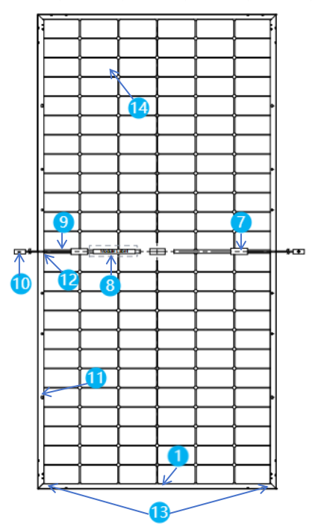3.serial number： Each module has a unique serial number. They are pasted in three parts of the module: the front and top bus bar of the module、Back glass、frame.

|  |  |  |  |
| --- | --- | --- | --- |
| 1. Aluminum Frame | b73256fe6b430378d191547f119a3a1  2.Tempering glass | 3.Ecapsulating EVA | 4. Cell |
| 5. Back glass | 6. Silicone adhesive | 7. Junction Box | 8.Nameplate | |
| 9. Cable | 10. Connector | 11.Mounting hole | 12.Grounding hole | |
| 13. Drainage hole | 14. Cell |  |  |

Figure 1 Module profile structure and component description

## General safety

Cloud Live Tech Solar Modules are designed to comply with international IEC 61215 and IEC 61730 standards, and its application rating is Class A: modules can be used in systems that are potentially accessible to the public and greater than DC 50V or 240W. The modules have passed IEC 61730-1 and IEC 61730-2 and meet the requirements of Safety Class II.

When modules are installed on roofs, the overall fire protection level of the final structure needs to

be considered. At the same time, we need to consider the overall maintenance in the later period. The roof photovoltaic system can only be installed on the roof, including the weight of the photovoltaic module itself, which has been evaluated by construction experts or engineers, has formal and complete structural analysis results and has been proved to withstand additional system support pressure.For your safety, please do not work on the roof without safety precautions, which includes, but are not limited to, fall protection, ladders or stairs and personal protective equipment.

For your safety, please do not install or process modules in adverse environments, including but not limited to strong winds or gusts, damp or sandy roofs.

## Electrical performance safety

Photovoltaic products generate direct current in the light, so touching the connector metal of the module can cause electric shock or burns. A 30V DC voltage or higher voltage is potentially fatal.

Modules also generate voltage without connecting the load or the external circuit. When operating modules in the sun, using insulating tools and wearing rubber gloves at the same time.

Modules have no switches. Only by removing the module from the light or shielding it with cloth, cardboard or completely opaque materials, or by placing the front of the module on a smooth、flat surface, can stop the module from working.

In order to avoid the danger of arc and electric shock, do not disconnect the electrical connection under load. The wrong connection can also lead to arcs and shocks. Connectors must be kept dry and clean to ensure that they are in good working condition. Do not insert other metal objects into connectors or make electrical connections in any other way.

Snow and water in the surrounding environment will increase light intensity by reflecting light, which in turn increases current and output power. In addition, the voltage and power of the module will increase correspondingly at low temperature.

If modules glass or packaging material are damaged, Wearing personal protective devices and separating modules from the circuit. Modules can only work in dry conditions and only use dry tools. Do not operate modules when they are wet unless appropriate electric shock protection equipment is worn; clean modules according to the requirements of this manual.

## Operational safety

During the transportation and storage of modules, unless the modules arriving at the installation site, please do not open the packaging of Cloud Live Tech Solar; please protect the packaging from damage; prohibiting the direct drop of packaged modules.

When stacking modules, do not exceed the maximum number of layers printed on the package carton; before opening the package, put the carton in a ventilated, rain-proof and dry place; when opening the carton , please following the instructions of Cloud Live Tech Solar .

In any case, it is forbidden to pick up the whole module by grabbing the junction box or cable . Do not stand or walk on the modules.

When lifting modules, it is forbidden to drop one module on another.

In order to avoid glass breakage, please do not put any heavy objects on the glass.

When placing modules on the ground, careful operation should be taken to prevent them from falling. Broken glass can be harmful, and broken glass modules can not be reused. Broken or damaged modules must be handled carefully and specially.

When placing a module on a flat surface, please handle it with care, especially in the corner; do not attempt to disassemble the module, nor remove the nameplate or the component.

Do not paint or apply any other adhesives on the surface of modules; avoiding damage to the Back glass of modules, and do not grab or scratch the Back glass of modules.

It is forbidden to drill holes in the frame, which may reduce the load capacity of the frame and cause the frame to corrode.

Do not scratch the anodic oxide layer on the aluminum alloy frame surface except when grounding. Scratches may cause frame corrosion and affect the load capacity of the frame.

Prohibiting self-repair of the modules that glass or Back glass damaged .

Under normal conditions, a photovoltaic module is likely to experience conditions that produce more current and/or voltage than reported at standard test conditions. Accordingly, the values of ISC and VOC marked on this module should be multiplied by a factor of 1,25. when determining component voltage ratings, conductor current ratings, and size of controls connected to the PV output.

Reverse current overload rating: the maximum over-current protection rating of each Module × 1.35

## Fire safety

Before installing the modules, please consult the local laws and regulations to comply with the building fire protection requirements. According to IEC 61730-2 standard, the fire protection level of Cloud Live Tech Solar Modules is Class C.

When modules are installed on the roof, the roof must be covered with a layer of fire-proof material suitable for this grade, and ensure adequate ventilation between the Back glass and the installation surface.

Different roof structures and installation methods will affect the fire safety performance of buildings. If not properly installed, it may cause fire. In order to ensure the level of fire protection on the roof, the minimum distance between the module frame and the roof surface is 10 centimeters.

Use appropriate accessories such as fuses, circuit breakers and grounding connectors according to local regulations. Do not use modules if flammable gases are exposed nearby.

the Modules passed UL 790 class C fire tests, the slope of tested module is 5 inches (127 mm) to the horizontal foot (0.3m), which is the most severe condition For roof-top installations, the roof must be covered with at least one layer of fireproof material suitable for the fireproof class of the PV modules。

Please use appropriate module components to comply with local laws and regulations, as well as the building fire safety requirements before installation, such as fuses, circuit breakers and grounding connectors, etc...

# Installation conditions

## Installation location and working environment

Modules can only be used on Earth, not in space.

Do not use mirrors or magnifiers to artificially focus sunlight on modules.

Modules must be installed in suitable buildings, or in other suitable places (such as ground, garage, building exterior wall, roof, photovoltaic tracking system), and modules cannot be installed in any type of mobile vehicle.

Do not install modules where they are likely to be flooded.

Cloud Live Tech Solar recommends modules are installed in the working environment of - 20 ~46 C. The working environment temperature is the highest and lowest monthly average temperature of the installation site. The limit working environment temperature of the module is - 40 ~85 C.

Ensure that the wind or snow pressure on the module after installation does not exceed the maximum allowable load.

Modules need to be installed in shadowless places throughout the year. Make sure there are no barriers to light at the installation site.

If modules are installed in places where frequent lightning activities occur, lightning protection of modules must be carried out. Do not install modules where flammable gases may appear nearby.

No modules shall be installed or operated in areas with severe pollution such as hail, snow,sand, dust, air pollution and smog. The modules shall not be placed in the environment existing corrosive substances such as salt, salt mist, salt water, chemically active steam, acid rain, or any other type of corrosive medium which may affect the safety and/or performance of the modules.

If the modules are installed on the area of snow, low temperature, strong wind and region around surface water ,the area vulnerable to the corrosion of brine, island, desert and so on,take appropriate steps to ensure the reliability and security.

Cloud Live Tech Solar Modules have passed the salt spray corrosion test of IEC61701, but the corrosion may occur in the parts where the frame connected to the bracket, or where the grounding connection is located. Cloud Live Tech Solar Modules can be installed in a place less than 500m but more than 50m away from the coastline. However, stainless steel or aluminum must be used to contact the module, and anti-rust treatment should be done on the installation site. Detailed installation requirements can be seen in the instructions of the Cloud Live Tech Solar seaside installation.

Modules should be installed in locations where the altitude is less than 2000m.

## Choice of tilt angle

The tilt angle of the module is measured between the module surface and the horizontal ground. Module generates maximum power output when it faces the sun directly.

In the northern hemisphere, modules are best installed to face south, in the southern hemisphere, modules are best installed to face north.

For detailed installation angles, follow the standard module installation guidelines or advice from experienced PV module installers.

# Mechanically installation

## Conventional requirements

It is necessary for the bracket installer to ensure that the module mounting method and bracket system are strong enough to withstand all predetermined load conditions. Installation brackets must be inspected and tested by a third-party testing agency with static mechanical analysis capability, using local national or international standards such as DIN1055 or equivalent.

The module mounting bracket must be made of durable, corrosion-resistant and ultraviolet-resistant materials.Modules must be firmly fixed to the mounting bracket.

In areas with large snow cover in winter, choosing a higher mounting bracket. The lowest point of the module will not be covered by the snow for a long time. In addition, the lowest point of the module is high enough to avoid being blocked by plants and trees, or being damaged by flying sand.

Module frame will have thermal expansion and contraction effect. When installed, the distance between adjacent two modules can not be less than 10mm.

Ensure that the Back glass of the module does not touch the bracket or building structure that can enter the module, especially when there is external pressure on the surface of the module.

The maximum static load passed by the module is 2400Pa on the back (equivalent to wind pressure) and 5400Pa or 2400Pa on the front (equivalent to snow pressure and wind pressure), depending on the type of installation of the module (see the installation method below).

The module installation method can not cause electrochemical corrosion between the aluminium frame and different metals. In the appendix of UL1703 standard《Flat Plate Photovoltaic Modules and Panels》, it is recommended that the electrochemical potential difference of metals in contact should not exceed 0.6V.

Modules are installed horizontally and vertically.

## Installation methods

Modules can be installed on the frame using mounting holes、Fixture or embedded system. You must install the module based on the following instructions and recommendations. If the installation method is different from the following, please consult Cloud Live Tech Solar and get the consent of Cloud Live Tech Solar, Otherwise, modules will be damaged and render the warranty void.

### Modules installed with mounting holes

Fix the module on the bracket with bolts through the mounting holes on the back frame of the module. See figure 2 for installation details：

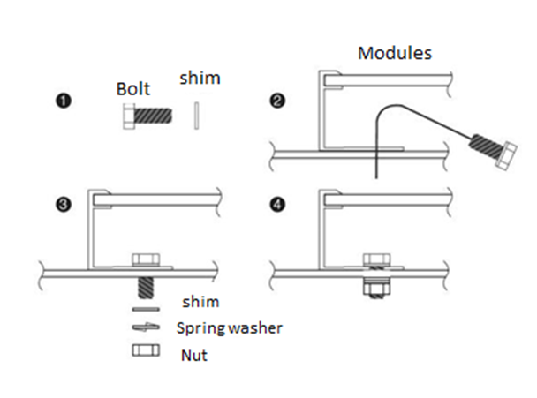

Figure 2. Mounting

The recommended accessories are as follows:

1. Bolt 2. Gasket

Material: stainless steel Material: stainless steel

Size and length：M8*16mm Size: M8

3. Spring gasket 4. Nut

Material: stainless steel Material: stainless steel

Size: M8 Size: M8

Screw tightening torque range：14 N▪m to 20 N▪m.

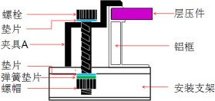

### Installation connection point position instructions

* + - * Load conditions at low/normal levels are suitable for most environmental conditions: the maximum static load on the back of the module is 1600 Pa (equivalent to wind pressure), and the maximum static pressure on the front is 2400 Pa (equivalent to wind pressure and snow pressure).
      * Higher load conditions, suitable for harsh environmental conditions (such as storms, snow, etc.): the maximum static load on the back of the module is 2400 Pa (equivalent to wind pressure), and the maximum static pressure on the front is 5400 Pa (equivalent to wind pressure and snow pressure), which is also the highest standard requirement of pressure in IEC standards.

For dynamic loads, such as gusts, it is necessary to increase the safety factor by three times, i.e., the maximum endurance of gust pressure is ±800Pa, i.e., the wind speed is less than 130 km.



Figure 3 Installation connection point location requirements

# Electrical installation

## 6.1 Electrical performance

Electrical performance parameters of the module such as Isc, Voc and Pmax have an error of (±3%) compared with the standard test conditions. Standard test conditions for components: irradiance 1000W/m2, battery temperature 25 C, atmospheric quality AM1.5.

Normally, the current and voltage values generated by module products may be higher than those obtained under standard test conditions. Therefore, when determining the parameters related to the rated voltage, conductor capacity, fuse capacity and module power output, the corresponding short-circuit current and open-circuit voltage should be amplified by 1.25 times.

When the modules are connected in a string, the final voltage is the sum of the individual modules. When the modules are paralleled in parallel, the final current is the sum of the individual modules, as shown in Figure 5 below.

Modules of different types of electrical performance cannot be connected in one series.

Series connection

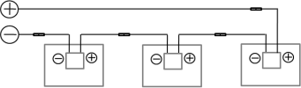

Parallel connection

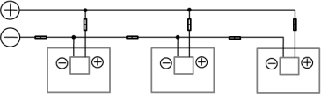

Series and parallel connection

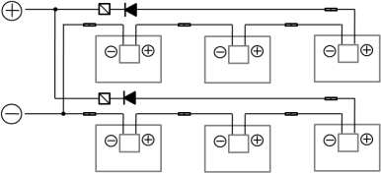



Figure 4 Electrical diagrams of series and parallel lines

The maximum number of series modules that connected in series must be calculated according to the requirements of relevant regulations. The value of open circuit voltage under the local minimum temperature can not exceed the maximum system voltage specified by the modules (according to IEC61730 safety test and appraisal, the maximum system voltage of Cloud Live Tech Solar Modules is DC1500V) and other value required for DC electrical components.

The open-circuit voltage correction factor can be calculated according to the following formula: (Voc=1-βVoc×(25-T), T is the lowest ambient temperature expected at the system installation location, and β(% /℃)is the temperature coefficient of the selected module Voc (refer to the corresponding module parameter table).

If there may be a reverse current passing through the module that exceeds the maximum fuse current of the module, the module must be protected by an overcurrent protection device of the same specification. If the number of parallel connection is greater than or equal to 2 series, there must be an overcurrent protection device on each series of modules.

The maximum number of series and parallel of photovoltaic modules is as follows:

Parallel module configurations: fuse rating/Isc.

System voltage＝N×Voc×｛1＋TCvoc×（25－Tmin）｝

## Cable and wire

In the design of modules, on-site connections use sealed junction boxes with IP67 level of protection, which provide environmental protection for conductors and their corresponding connections, as well as contact protection for uninsulated live modules. The junction box has well-connected cables and connectors with IP67 protection level. These designs facilitate the serial connection between modules. Each module has two wires separately connected to the junction box, one positive and one negative. The two modules can be connected in series by inserting the positive interface at the other end of the module wire into the socket of the negative conductor of the adjacent module.

The cables used to connect modules in the field must be able to meet the maximum short-circuit current of the modules. Using the special light-resistant cables for photovoltaic system.

Minimum standards for field cables used to connect modules are:

|  |  |  |
| --- | --- | --- |
| Test standard | Linediameter | Temperature range |
| TÜV 2 PfG 11694 | 4mm2 | -40ºC ~+90ºC |

When the cable is fixed on the bracket, it is necessary to avoid mechanical damage to the cable or modules. Do not press hard on the cables. For fixing cable by proper way, special designed light-resistant tie-up wire and wire clip must be used to fix the cable on the bracket. Although cables are light-resistant and waterproof, they should also be protected from direct sunlight and water immersion.

## Connector

PV connector model/types and manufacturer to which the module connectors shall be mated.

Keep the connector dry and clean. Make sure that the connector nut is tightened before connecting. Do not connect the connector when the connector is wet, dirty or otherwise. Avoid connectors being exposed to direct sunlight and immersed in water. Avoid connectors falling on the ground or roof.

The wrong connection may produce arcs and shocks. Please check that all electrical connections are reliable. Ensure that all connectors with locking are fully locked.

## Bypass diode

The junction box for Cloud Live Tech Solar Module contains by-pass diodes in series and parallel with the photovoltaic cell. In the case of partial shading, the diode bypasses the current generated by the non-shading unit, thereby reducing the heating and performance loss of the module. Note that bypass diodes are not overcurrent protection devices.

If diode failure is known or suspected, the installer or repairer should contact Cloud Live Tech Solar. Never try to open the terminal box by yourself.

|  |  |  |
| --- | --- | --- |
| Junction box | Zhejiang Jiaming Tianheyuan  Photovoltaics Technology Co., Ltd. | Type: JM0726  DC1500V, 30A, -40 to +85°C, IP65/IP68(1m,1h) |
| Connector for Photovoltaic system | Zhejiang Jiaming Tianheyuan  Photovoltaics Technology Co., Ltd. | Type: PV-JM608, 1500VDC, Rated current 30A, IP68 |
| Bypass diode | Zhejiang Jiaming Tianheyuan  Photovoltaics Technology Co., Ltd.  (OEM: Hangzhou LionMicroelectronics Co.,Ltd./Hangzhou DaomingMicroelectronics TechnologyCo., Ltd) | Type: RT3550 for 30A  Max. peak reverse voltage 50V  Forward Rectified current 35A.  Max junction temperature 200° C  No. of bypass diodes: 3 |

# Grounding

The anti-corrosive aluminium alloy frame with anodic oxidation is used as rigid support in the design of the module. In order to use it safely and avoid lightning and electrostatic damage to the module, the module frame must be grounded.

When grounding, the grounding device must be fully contacted with the inside of the aluminum alloy to penetrate the oxide film on the surface of the frame.

### Do not drill any additional grounding holes in the frame of the module.

In order to obtain the best power output, Cloud Live Tech Solar recommends that the DC negative pole of the module array be grounded when the module is installed. If this requirement is not followed, the power output of the system may be reduced.

The grounding method can not lead to electrochemical corrosion between the aluminium frame and different metals. In the appendix of UL1703 standard《Flat Plate Photovoltaic Modules and Panels》, it is recommended that the electrochemical potential difference of the metal in contact should not exceed 0.6V.

Borders have been pre-drilled and marked with grounding marks. These holes are used only for grounding, not for assemblies。

Modules allow the following grounding methods：

## 7.1 Grounding with grounding fixture

There is a grounding hole 4 mm in diameter in the middle edge of the back frame of the module. The median line of the grounding mark coincides with the median line of the hole, which is consistent with the length direction of the border.

Grounding between modules must be certified by qualified electricians,grounding devices must be manufactured by qualified electrical manufacturers. The recommended torque value is 2.3N·m. The grounding fixture uses 12AWG size copper core wire. Copper wires should not be damaged during installation.

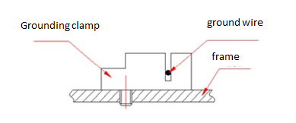

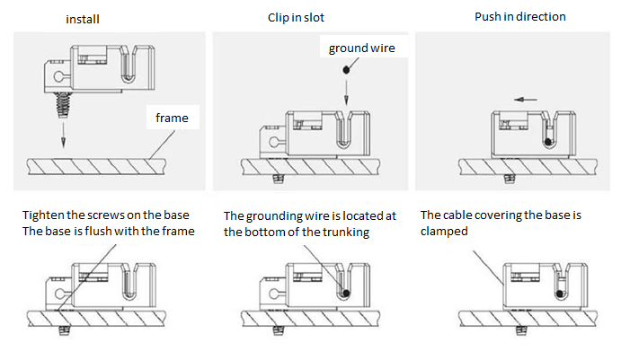

Figure 5 Installation mode of grounding fixture

Note: The figure above uses TYCO. 1954381-1 (recommended)

## Grounding with unused mounting holes

The existing but unused mounting holes on the modules can be used to install grounding devices.

1、Align the grounding fixture to the mounting hole of the frame. Use grounding bolt to pass through grounding fixture and frame.

2、Put the toothed gasket on the other side and screw the locking nut. The recommended tightening torque of the nut is 2.0N.m~2.2N.m.

3、If the grounding wire is passed through the grounding fixture, the material and size of the grounding wire should meet the relevant regulations, laws and standards of local countries and regions.

4、Tightening the grounding wire to fasten the bolt, and then install it.

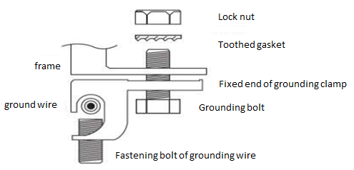

Figure 6 Installation method

## 7.3 Other third-party grounding devices

The third-party grounding device can be used to ground the Cloud Live Tech Solar Module, but the grounding must be reliable and proven. The grounding device is operated according to the requirements of the manufacturer.

# Operation and maintenance

Modules need to be checked and maintained regularly, especially within the warranty. The user is responsible for reporting any damage to the supplier within 2 weeks.

## 8.1 Cleaning

The accumulation of dust on the former transparent substrate can reduce power output and even cause local hot spot effects. Industrial effluent or bird drops may be severe, depending on the transparency of the foreign objects. Accumulated dust reducing sunlight exposure is generally harmless, as light intensity remains uniform and power reduction is usually not noticeable.

When modules work, there should be no environmental factors that cast shadows, covering parts or even entire modules, such as other modules, system support, bird drops and lots of dust, clay, or building, which can significantly reduce power output. Cloud Live Tech Solar advises that at no time should there be obstacles on the surface of the module.

The frequency of cleaning depends on the cumulative frequency of dirt. In many cases, the front surface of the module will be washed by rain, and we can reduce the frequency of cleaning. It is recommended to wipe the glass surface with a wet sponge or cloth. Please do not clean the glass with an acid or alkali cleaner.

* 1. **Visual inspection of modules**

Inspect the modules visually to find whether there are appearance defects, special attention should be paid to the following:

1、Whether the glass is broken.

2、Corrosion along the cell’s bus-bar. Corrosion is caused by moisture infiltration modules due to damage to encapsulating materials during installation or transportation.

3、Whether there is burning vestige on the Back glass.

* 1. **Inspection of connector and cable**

The following preventive maintenance is recommended every 6 months:

1、Check the encapsulation of the cable connector.

2、Check the sealant of the junction box to make sure there are no cracks or gaps.

9

# 9 Electrical performance parameters

|  |  |  |  |  |  |  |  |  |
| --- | --- | --- | --- | --- | --- | --- | --- | --- |
| 序号 | 组件规格型号 | 功率（W） | 组件尺寸(mm) | Vm（V） | Im（A） | Voc（V） | Isc（A） | 最大系统电压（V） |
| 1 | ZKM415N-54HL-DG | 415 | 1722× 1134× 30 | 31.70 | 13.10 | 37.70 | 13.91 | DC1500V |
| 2 | ZKM420N-54HL-DG | 420 | 1722× 1134× 30 | 31.90 | 13.17 | 37.90 | 13.98 | DC1500V |
| 3 | ZKM425N-54HL-DG | 425 | 1722× 1134× 30 | 32.10 | 13.24 | 38.10 | 14.05 | DC1500V |
| 4 | ZKM430N-54HL-DG | 430 | 1722× 1134× 30 | 32.30 | 13.32 | 38.30 | 14.12 | DC1500V |
| 5 | ZKM435N-54HL-DG | 435 | 1722× 1134× 30 | 32.50 | 13.39 | 38.40 | 14.18 | DC1500V |
| 6 | ZKM440N-54HL-DG | 440 | 1722× 1134× 30 | 32.70 | 13.46 | 38.60 | 14.25 | DC1500V |
| 7 | ZKM470N-60HL-DG | 470 | 1906× 1134× 30 | 35.69 | 13.17 | 43.30 | 13.69 | DC1500V |
| 8 | ZKM475N-60HL-DG | 475 | 1906× 1134× 30 | 35.88 | 13.24 | 43.45 | 13.77 | DC1500V |
| 9 | ZKM480N-60HL-DG | 480 | 1906× 1134× 30 | 36.06 | 13.31 | 43.60 | 13.85 | DC1500V |
| 10 | ZKM485N-60HL-DG | 485 | 1906× 1134× 30 | 36.25 | 13.38 | 43.76 | 13.93 | DC1500V |
| 11 | ZKM490N-60HL-DG | 490 | 1906× 1134× 30 | 36.43 | 13.45 | 43.91 | 14.01 | DC1500V |
| 12 | ZKM570N-72HL-DG | 570 | 2278× 1134× 35 | 43.58 | 13.08 | 52.10 | 13.83 | DC1500V |
| 13 | ZKM575N-72HL-DG | 575 | 2278× 1134× 35 | 43.73 | 13.15 | 52.30 | 13.89 | DC1500V |
| 14 | ZKM580N-72HL-DG | 580 | 2278× 1134× 35 | 43.88 | 13.22 | 52.50 | 13.95 | DC1500V |
| 15 | ZKM585N-72HL-DG | 585 | 2278× 1134× 35 | 44.02 | 13.29 | 52.70 | 14.01 | DC1500V |

temperature coefficient for voltage at open-circuit: 0.047%/°C

temperature coefficient for maximum power: -0.255%/°C

temperature coefficient for short-circuit current: -0.296%/°C